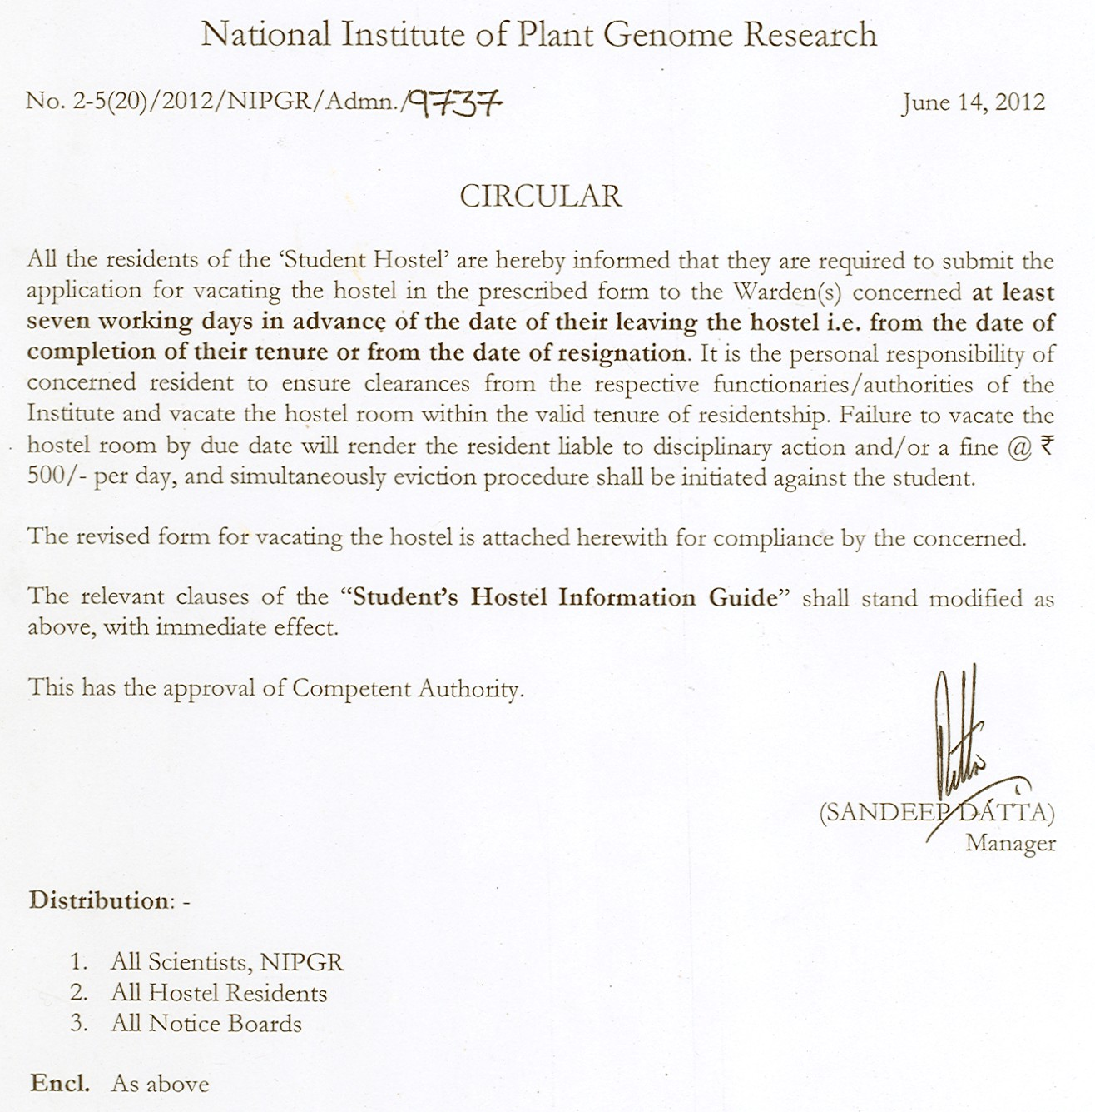

FORM C
National Institute of Plant Genome Research

APPLICATION FOR VACATING THE HOSTEL
(to be filled in triplicate)

Part-I
The Warden (Boys/Girls)
National Institute of Plant Genome Research

Sir/Madam,

Kindly permit me to leave the hostel with my personal belongings on ________________ and refund my security deposit after adjusting dues, if any. My future address is given below.

I will be completing my tenure in the Institute on ______________________.
or
I am resigning from my position at the Institute on _____________________.
Yours faithfully,
Address for future correspondence / Pin.…………………….. Signature of the resident …………………………

……………………………………………………………………..…….. Name of the resident …………………………….

………………………………………………………………..………….. Room No. ……………………………………..

Telephone No. …………………………………………

Countersigned by the supervisor

Signature of the supervisor …………………………..

Name of the Supervisor ……………………………..

Part-II

Duration of the Hostel Accommodation ……………………………

Dealing Assistant/JMA

Administrative Officer

Part-III

No dues are outstanding from him/her. He/She has been billed for the whole period up to ________________________________.
Mess Manager ………………………………….

No dues are outstanding from him/her. ……………………………………………………………………………………….

Dealing Assistant/JMA
Finance Officer

Part-IV

His/her room has been checked and all furniture and fixtures allotted to him/her have been found intact. Damages, if any have been recovered from him/her vide receipt No. _________________ dated __________. The possession/key of the room has been taken and nothing is due from him/her.

Caretaker's signature with date ….……………………….

J. E. (Civil) signature with date……………………………..

Countersigned by the A.O.

……………………………………………

Part-V

Shri/Smt./Km ……………………………………………… allottee of Room No. ………………………………. is permitted to leave the hostel along with his/her belongings.
Warden (Boys/Girls)
Note: 1. Caretaker
2. Security Guard to keep the original with him
3. Third copy for student's use.

Instructions
- The supervisor concerned of the students/researchers who discontinue their studies in the middle of a semester or are completing their tenure must ensure that the students/researchers should submit the application for vacating the hostel in the prescribed Form to the Warden(s) concerned at least seven working days in advance of the date of their leaving the hostel. The students/researchers are required to vacate the hostel on the date of their completion of tenure or on the date of resignation.
- Before vacating the hostel, each resident must hand over to the Caretaker & Engineering Section, the complete charge of his or her room with all furniture and fixtures intact, and clear all hostel and mess dues.
- The resident students while vacating or on being evicted from the hostel rooms will have to pay the cost of article(s) found either missing or damaged, allotted in his/her name, keeping in view the original price of the article(s) minus depreciation value, as may be decided by the Warden(s) of the Hostel concerned.
- Failure to vacate the hostel room by the due date will render the resident liable to disciplinary action or a fine (@ Rs. 500/- per day) or both, and simultaneously eviction procedure shall be initiated against the student.

