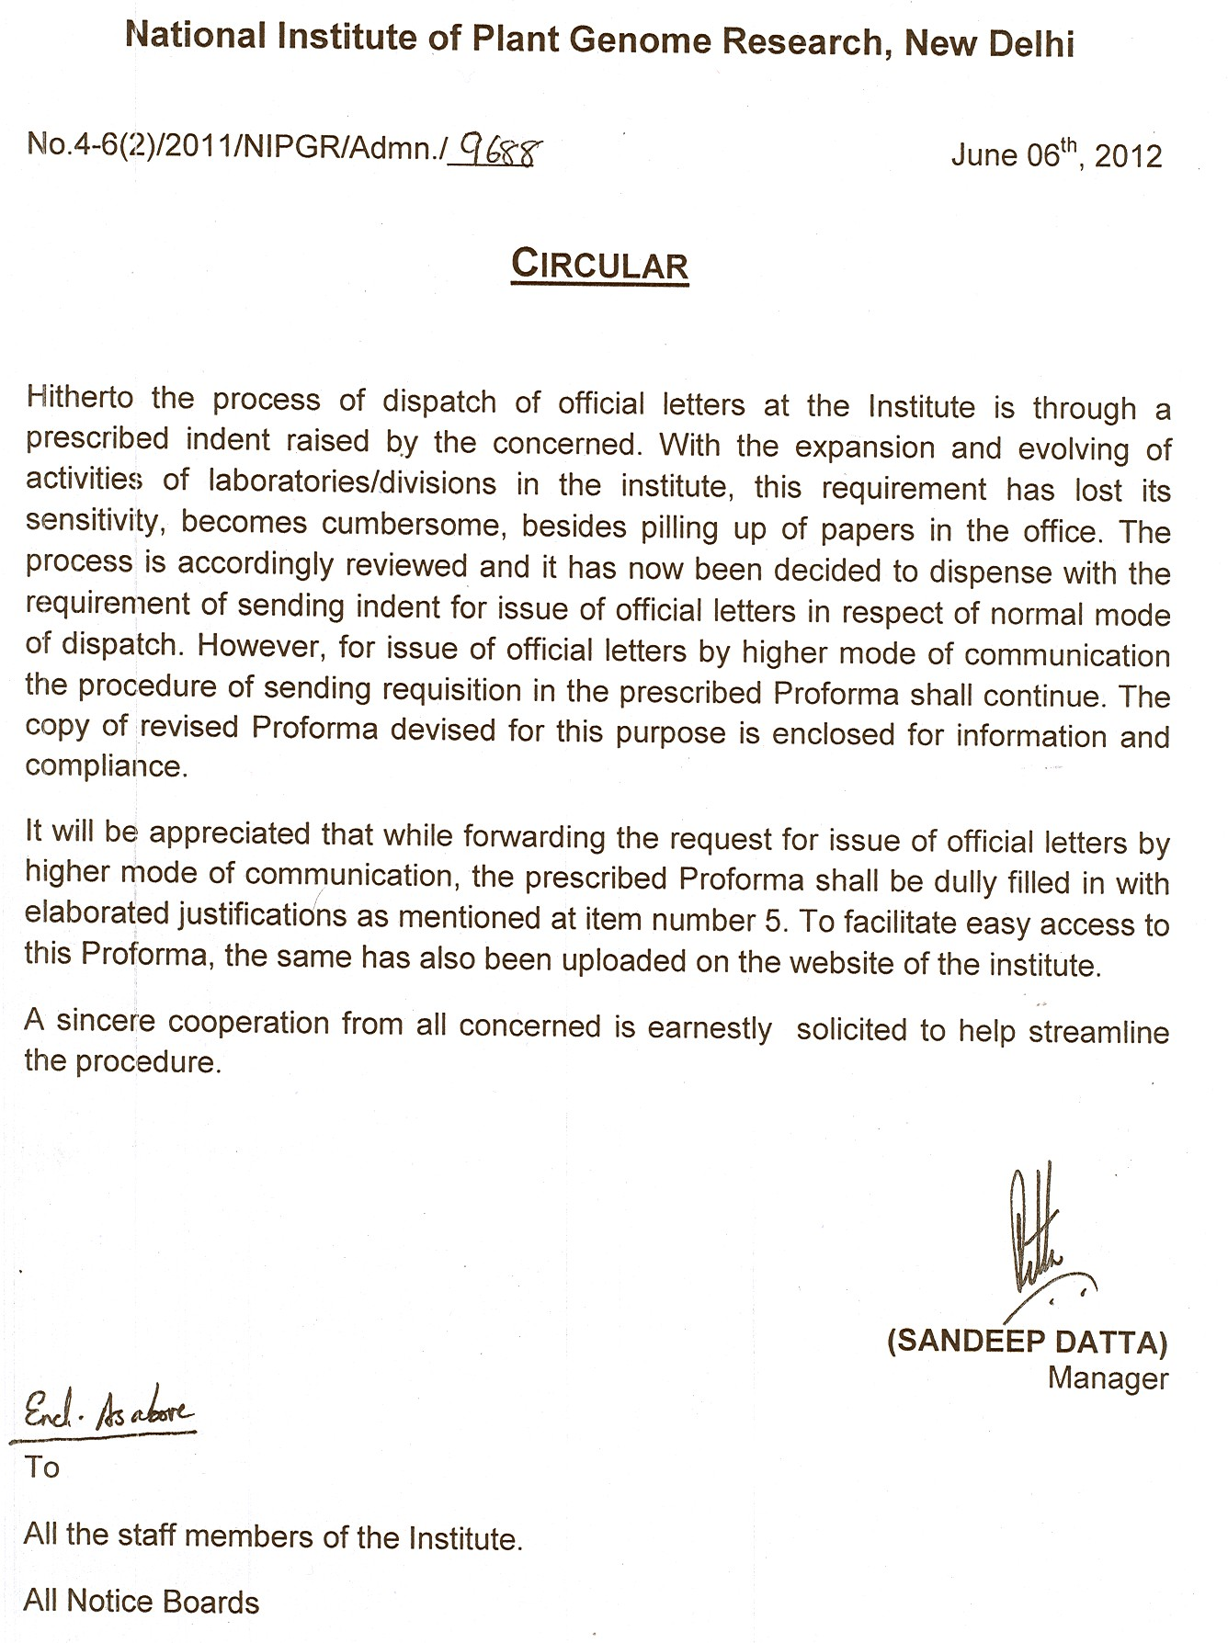

National Institute of Plant Genome research
New Delhi

performa
For dispatch of official letters by higher mode of communication

dated: ………………….

1. Name of Scientist/Officer: ………………………………………………………….

2. Lab No. /Division : ………………………………………………………….

3. Communication Address : (i) …………………………………………………………
of the Addressee to whom
is/are to be dispatched …………………………………………………………

…………………………………………………………

(ii)…………………………………………………………

…………………………………………………………

…………………………………………………………

4. Particulars of Communication: …………………………………………………………

5. Medium of Communication: Hindi / English / Bilingual (Plz. Tick)

6. Please specify:
a) Fresh letter ……………………………………………………..
b) Response to letter received earlier ……………………………………………..

7. Mode of Communication
(Regd.Post/Foreign Courier /Express Courier/Speed Post):……………………………………..
(Please give elaborated justifications)
…………………………………………

……………………………………...

Signature of the Scientist/Officer

Administrative Officer
NIPGR
New Delhi

